**Preliminary Analysis- Traffic Violation in Maryland**

There are 684754 entries of data from 01/01/2012 to 07/04/2015.

For each observation, the information includes:

|  |  |  |  |  |  |
| --- | --- | --- | --- | --- | --- |
| Date Of Stop | Time Of Stop | Agency | Sub-Agency | Description | Location |
| Latitude | Longitude | Accident | Belts | Personal Injury | Property Damage |
| Fatal | Commercial License | HAZMAT | Commercial Vehicle | Alcohol | Work Zone |
| State | VehicleType | Year | Make | Model | Colour |
| Violation | Type | Charge | Article | Contributed To Accident | Race |
| Gender | Driver City | Driver State | DL State | Arrest Type | Geolocation |

The core features of the observations for the analysis are determined as:

* Location (Latitude, Longitude)
* Gender
* Vehicle information (Makes, Car Type, Model)
* Violation information (Type of Violation, Time and Date)

**The distribution of the core features are stated below**

*Fig 1. Gender Distribution*

#### 

#### *Fig 2. Car Manufacturer Distribution(Top 5)*

#### 

#### 

#### *Fig 3. Vehicle Types Distribution (Top 5)*

#### 

#### *Fig 4. Violation Type Distribution (Top 5)*

#### 

#### *Fig 5. Car Model Distribution (Top 5)*

#### 

#### *Fig 6. Point Distribution of Locations*

**Analysis from the graphs above**

* Most of them who violated the traffic regulation are **male.**
* Most of the cars involved in traffic violation are manufactured by **Toyota.**
* Most of the cars involved in traffic violation are **automobile**.
* Most of the cars involved in traffic violation are of **model 4S**.
* The main reasonfor traffic violation is because driver **failed to obey the properly placed traffic control device instructions.**

For the vehicle type distribution, the differences are statistically significant as 85% of these cars are automobile.

**Other salient aspects of the data**

The dataset includes information on latitude and longitude of the locations of traffic violations. Description for traffic violations are in text.

**Next 5-10 tasks**

* Plot a heat map showing date distribution of traffic violations.
* Discover more correlations between the places of traffic violations and the actual road map.
* Plot various information by month to discover seasonal changes of the characteristics of traffic violations.
* Discover more correlations and difference between gender by separating the data by gender.

#### Find out the effect of alcohol on male and female.

#### Discover how the presence or absence of seat belts affects fatality .

**Correlation between gender**

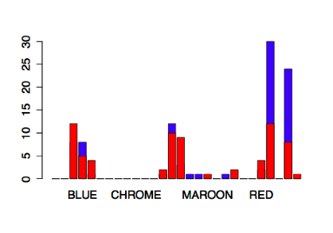

Plot 1

Red= Female, Blue= male who commit fatal

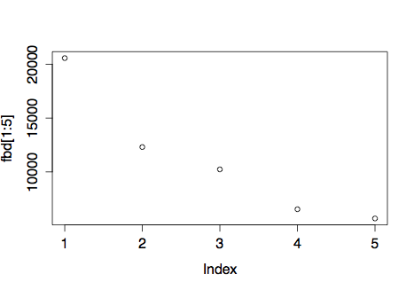

Plot2 means emales who belt=No dirver’s top5 description

In plot2, female driver failed because driver **failed to obey the properly placed traffic control device instructions.**

DATA:

FAILURE TO DISPLAY REGISTRATION CARD UPON DEMAND BY POLICE OFFICER

12308

DRIVING VEHICLE ON HIGHWAY WITH SUSPENDED REGISTRATION

10234

DRIVER FAILURE TO STOP AT STOP SIGN LINE

6533

DISPLAYING EXPIRED REGISTRATION PLATE ISSUED BY ANY STATE

5677

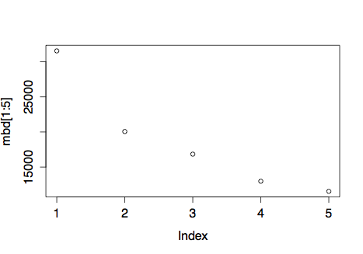

In plot3, male driver failed to obey the properly placed traffic control device instructions.

DATA:

DRIVER FAILURE TO OBEY PROPERLY PLACED TRAFFIC CONTROL DEVICE INSTRUCTIONS

31555

FAILURE TO DISPLAY REGISTRATION CARD UPON DEMAND BY POLICE OFFICER

20069

DRIVING VEHICLE ON HIGHWAY WITH SUSPENDED REGISTRATION

16842

OPERATOR NOT RESTRAINED BY SEATBELT

12986

FAILURE OF INDIVIDUAL DRIVING ON HIGHWAY TO DISPLAY LICENSE TO UNIFORMED POLICE ON DEMAND

11543

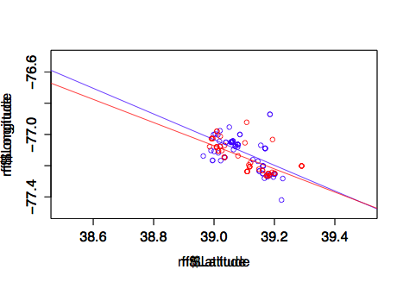

Plot4 means male(blue), female(red), who commit fatal. Plot with regression line

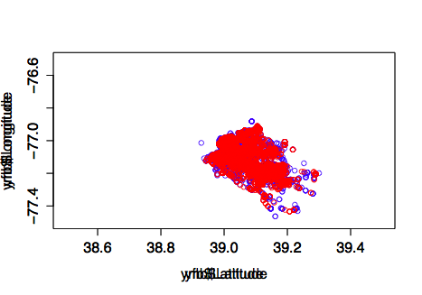

Plot6 means seat belt=Yes data plot

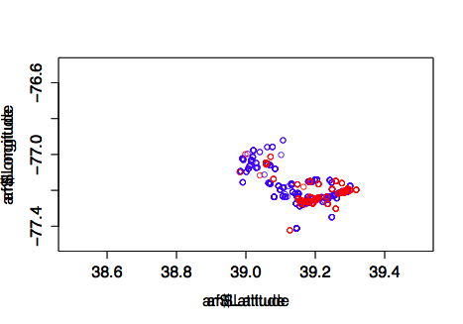

Plot7 means Alcohol = Yes data plot

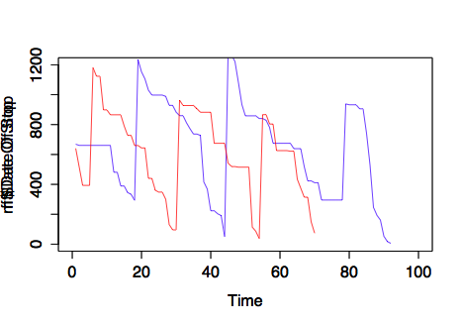

Plot 8 means data of time series in fatal from male, female

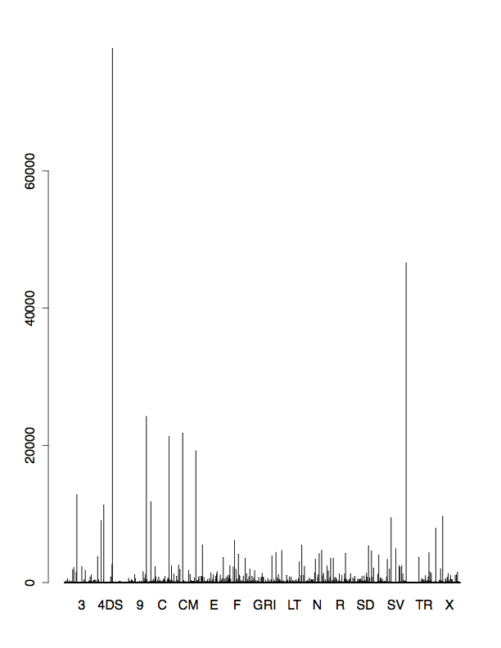The bar graph 'Model_accident' show the particular car model had been related to the accident in Maryland.

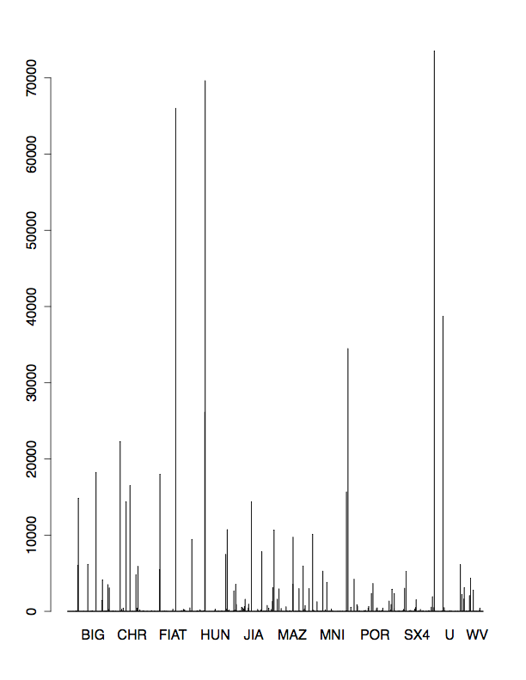

‘Maker_accident’, the same reason with above a maker of the car have related to accident of the car model.

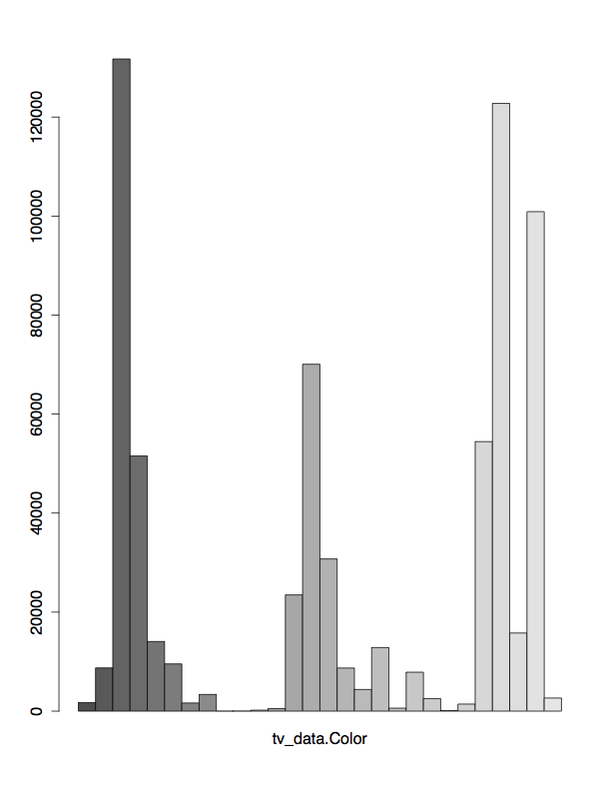

‘Colour_Accident’, car colours shows that several colours have higher frequency related with the accident

Done by: Outliers